**Insert School Logo**

**Semester One Examination 2019**

**Question/Answer Booklet**

**MATHEMATICS SPECIALIST**

**UNIT 1**

**Section Two:**

**Calculator–assumed**

Student Name: _____________________________________

Teacher’s Name: _____________________________________

**Time allowed for this section**

Reading time before commencing work: ten minutes

Working time for paper: one hundred minutes

**Material required/recommended for this section**

**To be provided by the supervisor**

This Question/Answer booklet

Formula Sheet (retained from Section One)

**To be provided by the candidate**

Standard items: pens(blue/black preferred), pencils(including coloured), sharpener, correction tape/fluid, erasers, ruler, highlighters

Special Items: drawing instruments, templates, notes on two unfolded sheets of A4 paper, and up to three calculators approved for use in the WACE examinations.

**Important note to candidates**

No other items may be taken into the examination room. It is **your** responsibility to ensure that you do not have any unauthorised notes or other items of a non–personal nature in the examination room. If you have any unauthorised material with you, hand it to the supervisor **before** reading any further.

**Structure of this paper**

|  |  |  |  |  |
| --- | --- | --- | --- | --- |
|  | Number of questions available | Number of questions to be attempted | Suggested working time (minutes) | Marks available |
| Section One  Calculator—free | 6 | 6 | 50 minutes | 53 |
| **Section Two**  **Calculator—assumed** | **10** | **10** | **100 minutes** | **97** |
|  | | | | 150 |

**Instructions to candidates**

1. The rules for the conduct of Western Australian external examinations are detailed in the *Year 12 Information Handbook 2019.* Sitting this examination implies that you agree to abide by these rules.
2. Answer the questions according to the following instructions.

Section Two: Write answers in this Question/Answer Booklet. Answer **all** questions.

**Show all your working clearly.** Your working should be in sufficient detail to allow your

answers to be checked readily and for marks to be awarded for reasoning. Incorrect

answers given without supporting reasoning cannot be allocated any marks. For any

question or part question worth more than two marks, valid working or justification is required to receive full marks. If you repeat an answer to any question, ensure that you cancel the answer you do not wish to have marked.

It is recommended that you **do not use pencil**, except in diagrams.

1. You must be careful to confine your responses to the specific questions asked and to follow any instructions that are specific to a particular question.
2. Spare pages are included at the end of this booklet. They can be used for planning your responses and/or as additional space if required to continue an answer.

* Planning: If you use the spare pages for planning, indicate this clearly at the top of the page.
* Continuing an answer: If you need to use the space to continue an answer, indicate inthe original answer space where the answer is continued, i.e. give the page number. Fill in the number of the question that you are continuing to answer at the top of the page.

1. The Formula Sheet is **not** handed in with your Question/Answer Booklet.

# Section Two: Calculator–assumed 97 marks

This section has **ten (10)** questions. Attempt **all** questions.

Write your answers in the spaces provided.

Working time: 100 minutes

**Question 7 (5 marks)**

Consider the points A(4, –5), B(–2, 4) and C(–6, 10).

(a) Show that these points are collinear. (3 marks)

(b) Determine the ratio in which point B divides the line segment AC. (2 marks)

**Question 8 (13 marks)**

The diagram below shows a circle with centre at O inscribed in the trapezium ABCD.

The sides of the trapezium are tangents to the circle at the points E, F, G and H.

PQ is a diameter to the circle, |EB| = 8 cm, |BC| = 11 cm and ∠FPO = 35° as shown.

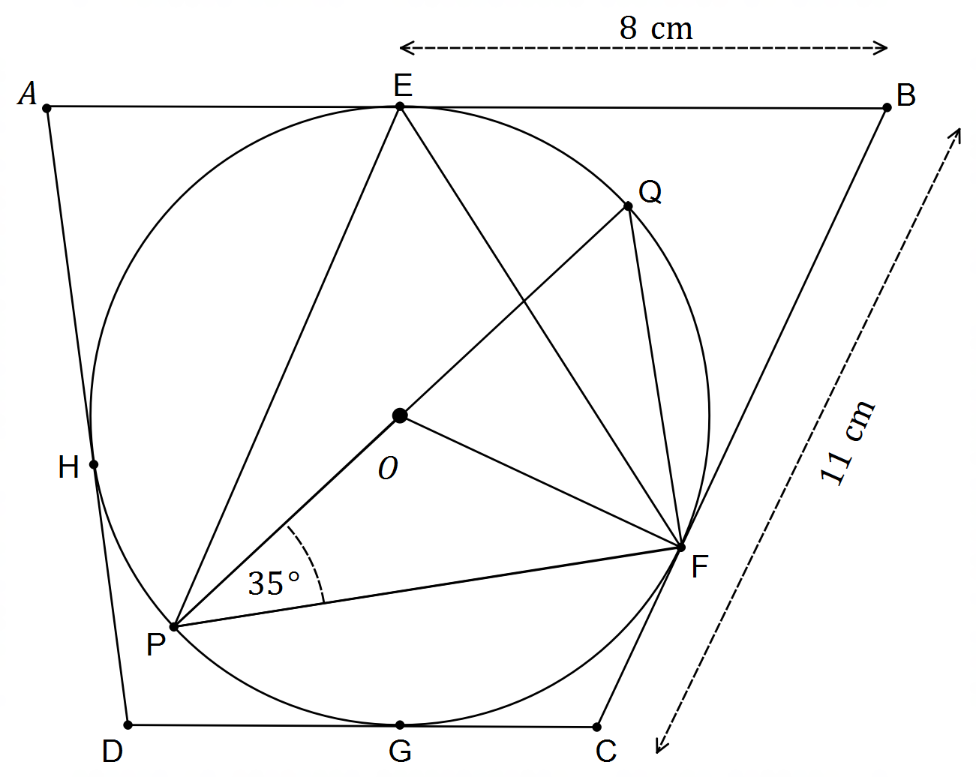

Determine the size of the following angles giving reason(s) to justify your answer.

(i.e. name the theorem used to obtain your answer)

(a) ∠PFO (2 marks)

(b) ∠FEP (2 marks)

(c) ∠PQF (2 marks)

**(Question 8 – Continued)**

(d) ∠CFP (2 marks)

(e) |GC| (2 marks)

(f) Add to the diagram a line segment that joins vertex A with the centre of the circle O.

This line segment intersects the circle at the point M.

If |AH| = 5 cm, and the radius of the circle is 4 cm, determine |AM|. (3 marks)

**Question 9 (8 marks)**

Consider the set $A=\left\{1, 2, 3, 4, …99, 100\right\}$, i.e. the set of natural numbers less or equal to 100.

Elements are chosen at random from this set without repetition of elements.

(a) What is the minimum number of elements that must be chosen to ensure that there is

at least one number is divisible by

(i) 3 and 5? (2 marks)

(ii) 3 or 5? (3 marks)

(b) What is the maximum number of elements that can be chosen making sure that

their sum does not exceed 1000?. Clearly justify your answer. (3 marks)

**Question 10 (6 marks)**

Private vehicles must be licensed to be allowed on our roads. Of the 16 366 households in greater Perth there are 7 531 that have at least one motorcycle licensed, 9 885 households have at least one car licensed, and 2 032 that have neither a motorcycle nor car a licensed.

(a) Show how to use the inclusion–exclusion principle for two–sets to determine the number of households in greater Perth that have at least both one car and one motorcycle licensed.

(3 marks)

Boats must also be licensed to be operated in our rivers and surrounding sea.

There are 4 977 homes which have at least one boat licensed, 4 310 that have both at least one car and one boat licensed, 2 252 have both at least one motorcycle and one boat licensed, and 1 724 that have all three (i.e. at least one car, one motorcycle and one boat licensed).

(b) Show how to use the inclusion–exclusion principle for three–sets to determine the number of homes surveyed that do not have any car, motorcycle or boat licensed. (3 marks)

**Question 11 (14 marks)**

(a) Four character passwords are created using letters of the alphabet and/or digits, and they are not case sensitive (i.e. capitals and lower case count as the same).

Repetition of characters is not allowed. How many different passwords can be created if:

(i) no other restrictions apply? (1 mark)

(ii) they must contain exactly two digits? (2 marks)

(iii) they must start and end with a vowel? (2 marks)

(b) Which of the expressions below can be used to calculate the total number of 8–digit PINs

that can be created without repetition of digits? Circle the correct answer(s). (2 marks)

I. ${}_{ }^{10}{C_{8}}$ II. ${{}_{ }^{10}C}_{8}×8!$ III. ${}_{ }^{10}{P_{8}}$ IV. ${}_{ }^{10}{P_{8}}×8!$

**(Question 11 – Continued)**

(c) Solve for $x$. Show working for full marks. (3 marks)

$${}_{ }^{x+1}{P_{3}}={}_{ }^{4}{C_{3}}×{}_{ }^{x}{P_{2}}$$

(d) Show that ${}_{ }^{n}{P_{2}}+2n={}_{ }^{n+1}{P_{2}}$ (4 marks)

**Question 12 (14 marks)**

A surveillance drone is hovering at $1200i-540j$ metres relative to the control tower at O, and

the drone can travel in still air at 25 m/s. There is a wind blowing from $080°T$ with a speed of $20$ m/s.

(a) State the velocity vector that the drone must have so that it remains stationary when counteracting the effects of the wind. (2 marks)

(b) The drone is required to fly directly back to the control tower to be recharged, and it must

do so taking into account the effects of the wind.

(i) Sketch a diagram of the situation on the axes below. (3 marks)

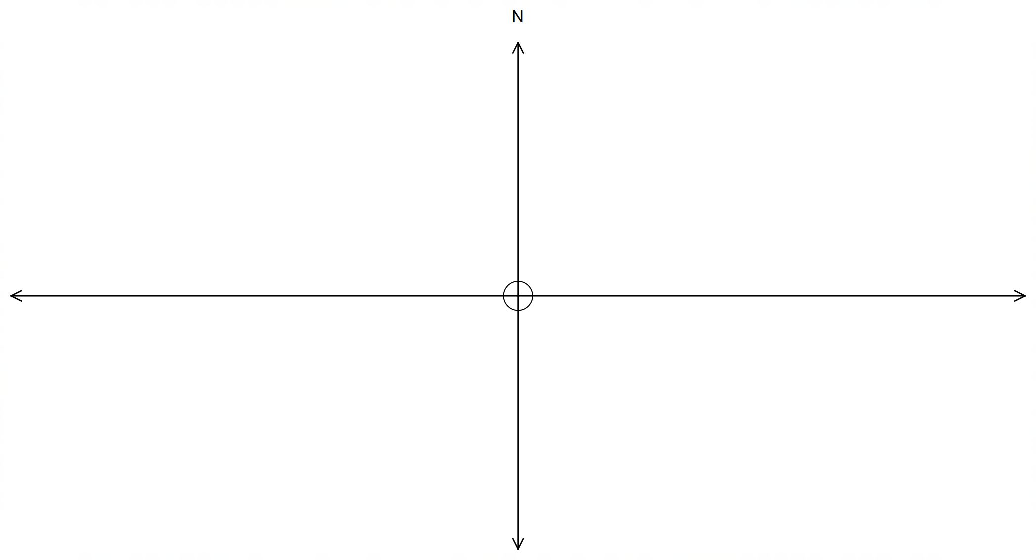

**(Question 12 – Continued)**

(b) (ii) State the velocity vectors of the wind $w$, drone $d$ and resultant $r$ in the format $\left(\begin{matrix}x \\ y\end{matrix}\right)$.

(3 marks)

(iii) Use the fact that $r=d+w$ to determine the bearing that the drone must set so

that it flies directly back to the control tower. Show working to justify your answers.

State the time it takes for the drone to get back to the control tower. (6 marks)

**Question 13 (7 marks)**

Two construction workers are trying to lift a delicate piece of machinery using two ropes.

The ropes are attached to the machinery at a fixed angle as shown. The machinery weighs 500N and both workers pull along their respective ropes at 300N and 252N as shown.

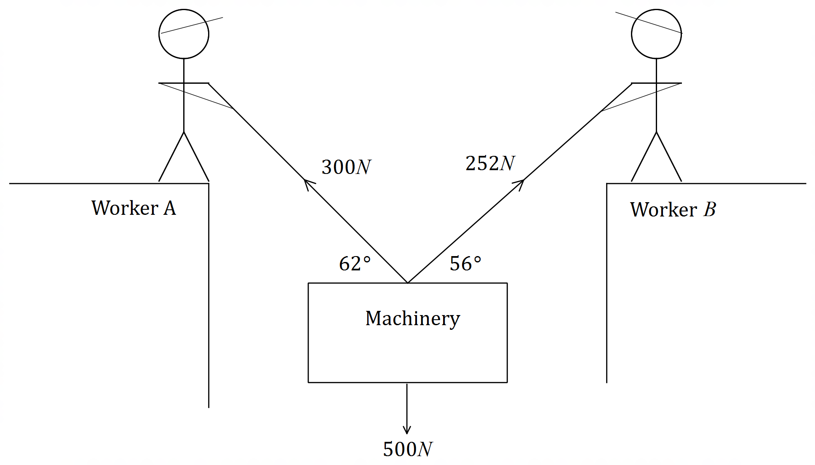

(a) Show that with the current setup the machinery is not moving upwards. (3 marks)

**(Question 13 – Continued)**

In order to get the machinery moving upwards, Worker A now pulls on his rope at 400N.

(b) Determine the force that Worker B must apply so that the machinery moves directly upwards.

(i.e. does not shift horizontally or move diagonally upwards. Assume the angles do not change) (2 marks)

(c) State the overall force exerted upwards by both workers using your answer in (b). (2 marks)

**Question 14 (15 marks)**

(a) Consider the following conjecture:

“ $∀ n∈N$, if $n$ is odd then $n^{2}+1$ is even.”

(i) Use direct proof to show that the conjecture is true $∀ n∈N$. (4 marks)

(ii) Use proof by contrapositive to show that the conjecture is true $∀ n∈N$. (4 marks)

**(Question 14 – Continued)**

(b) Consider the following statements:

A: “The quadrilateral has two diagonals that intersect at right angles.”

B: “The quadrilateral has two pairs of parallel sides”.

Determine the validity of A ⇔ B, by considering the validity of A ⇒ B and B ⇒ A. (3 marks)

(c) Use proof by contradiction to show that $∀ n∈N$, if $n$ is even, then $n^{2}$ is also even. (4 marks)

**Question 15 (10 marks)**

(a) The diagram below shows the vectors $\vec{OA}, \vec{OB}$ and $\vec{AB}$ forming a triangle, where $θ$ is the angle

between $\vec{OA}$ and $\vec{OB}$.

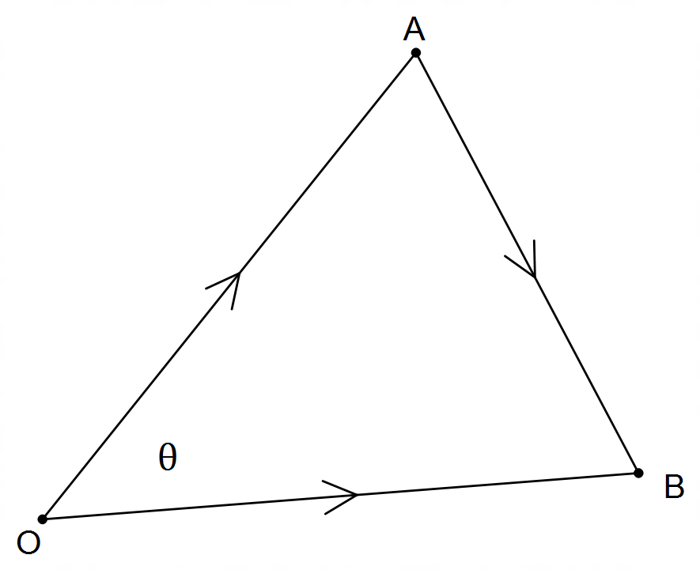

(i) Use the cosine rule to state a relationship between $\left|\vec{OA}\right|, \left|\vec{OB}\right|$ and $\left|\vec{AB}\right|$. (1 mark)

(ii) Use the fact that ${\left|r\right|}^{2}=r∙r$ to prove the dot product, i.e. that $u∙v=\left|u\right|×\left|v\right|×\cos{θ}$.

(4 marks)

**(Question 15 – Continued)**

(b) Vectors $\vec{OA}=4i+5j$ and $\vec{OB}=2i-3j$ have an angle $θ$ between them.

(i) Show working to find the exact value of $\cos{θ}$**and** hence determine whether $θ$ is

either acute or obtuse. (3 marks)

(ii) Using your answer in (i) above determine the exact value of $\sin{θ}$.

Hence, determine the exact area of triangle $OAB$. (2 marks)

**Question 16 (5 marks)**

The diagram below shows the quadrilateral $ABCD$, with $\vec{OA}=\left(\begin{matrix}-6 \\ 3\end{matrix}\right), \vec{OB}=\left(\begin{matrix}5 \\ 5\end{matrix}\right), \vec{OC}=\left(\begin{matrix}7 \\ -2\end{matrix}\right)$

and $\vec{OD}=\left(\begin{matrix}-4 \\ -6\end{matrix}\right)$. Show that the midpoints P, Q, R and S form a parallelogram.

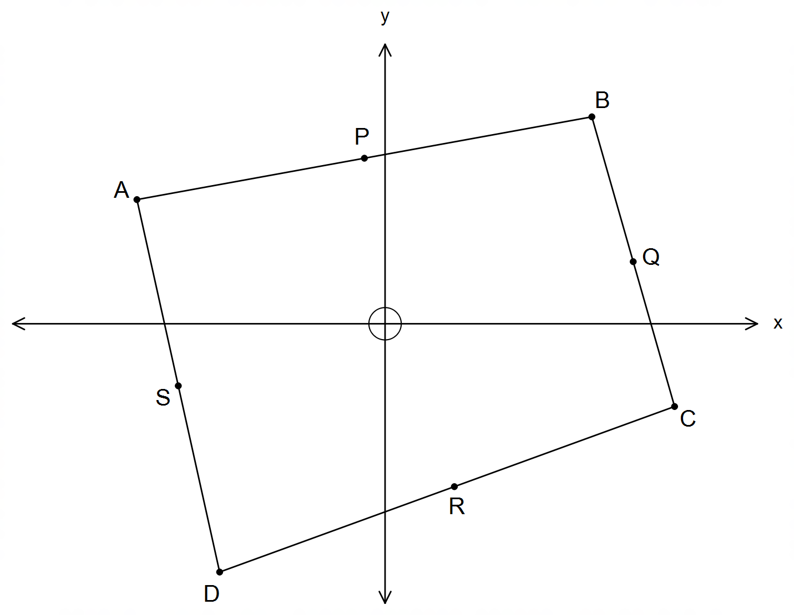

(5 marks)

(DELIBERATELY LEFT BLANK)

**END OF QUESTIONS**

**Additional working space**

Question number(s): ……………………

**Additional working space**

Question number(s): ……………………

**Additional working space**

Question number(s): ……………………

**Additional working space**

Question number(s): ……………………